Datto SaaS Protection

Datto SaaS Protection can support the following M365 license types.
- E1, E3, E5, Exchange only 1 and 2.
- SharePoint only 1 and 2
- Business Essentials
- Business Premium
- EDU
- GOV
- NPO
Custom Data Retention in Datto SaaS Protection
Custom Data Retention (CDR) allows Datto SaaS Protection administrators to select how long to retain user data. For further information see Datto SaaS Protection: Changing retention type and commitment length for client accounts

Selecting the user data retention period
From the Datto SaaS Protection dashboard, choose Settings from the top menu, then select Advanced settings from the drop-down menu.
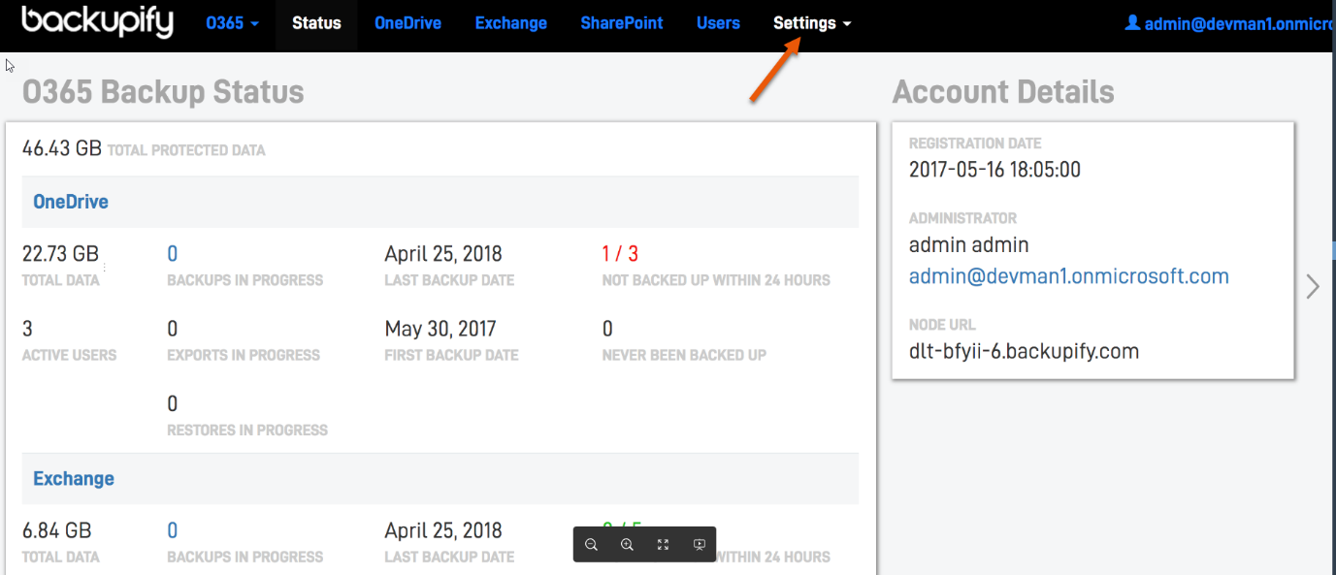
Figure 1: The Datto SaaS Protection dashboard
In Advanced settings, select the retention period from the drop-down menu. You can select presets for one, two, or three years, or infinite retention.
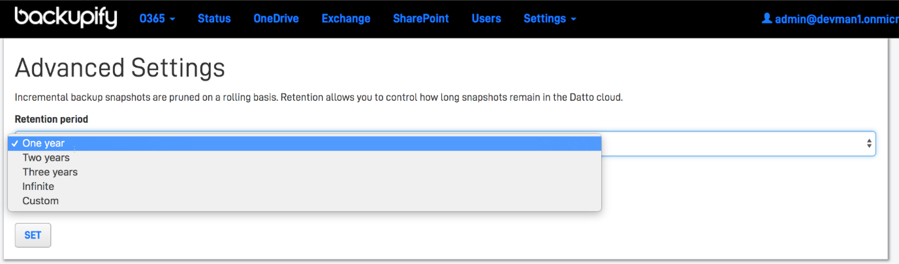
Figure 2: Advanced settings

Setting a custom retention period
To customize the retention period, select Custom from the Retention period drop-down menu, then enter the number of days to retain the data.
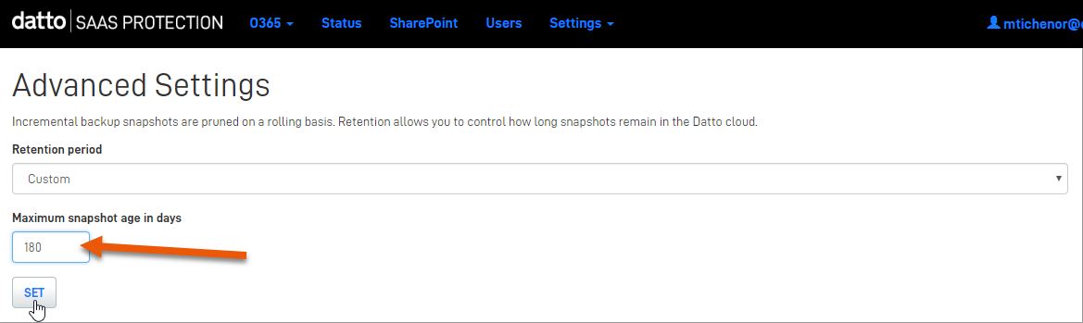
Figure 3: Setting custom retention

Pruning schedule for new clients
clients onboarded as of April 25th, 2018 will have their data subject to the following pruning schedule:
- All 3 daily user backups are retained & available for viewing for 30 days
- After 30 days, 1 daily backup is saved per service
- After 90 days, 1 weekly backup is saved per service
- After 1 year, 1 monthly backup is saved per service

Adding a new Datto SaaS Protection client

This article explains how to set up a client's Datto SaaS Protection account in the Datto Partner Portal. This process applies to partners of all regions.

- Datto SaaS Protection for Office 365
Datto Partner Portal
After completing the general steps of the initial setup below, continue to the service-specific steps for Office 365 or G Suite, depending on which service you are protecting.

Prerequisites
- If you have not yet opted into Datto SaaS Protection, follow the steps in How do I opt-in to Datto SaaS Protection through the Datto Store? before adding a new client.
- You must have Global Admin or Super Admin account credentials to the customer's Office 365 or G Suite
- To complete the setup and purchase, you must have Trusted Tech or Admin-level permissions in the Datto Partner Portal.

General steps
1. In the Datto Partner Portal, click the Status tab, then select SaaS Protection Status from the drop-down menu.
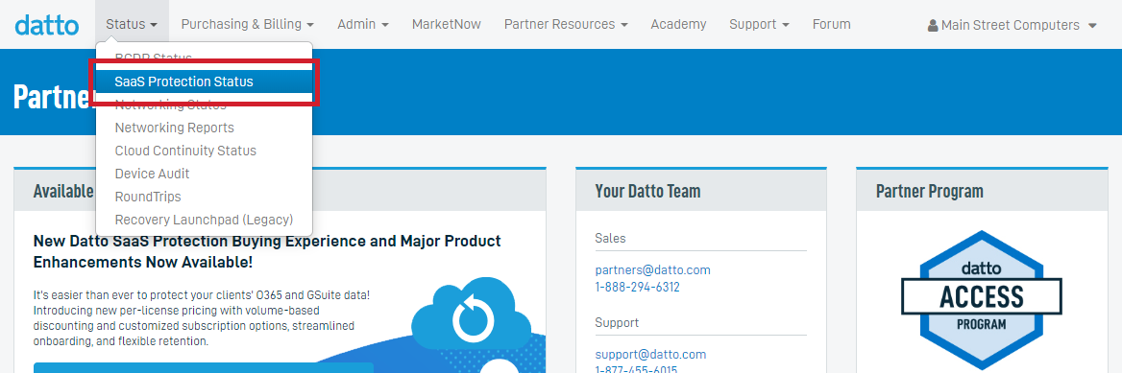Figure 1: The Datto Partner Portal
2. On the SaaS Protection Status page, click the ADD SAAS PROTECTION CLIENT button.
By default, the ADD SAAS PROTECTION CLIENT button is only visible to Admins. If you are an Admin and you wish to make this function available to a technician at your company, contact Datto Technical Support.
Figure 2: The SaaS Protection Status page
3. The Add SaaS Protection Client dialog box will appear. fill out the following sections:

Adding the client
- Select or create client: Enter a new client's name, or select an existing client from the drop-down menu.
- Region where data is stored: Choose the geographically appropriate storage region.
- Select which product will be backed up: Choose Office 365 or G Suite.
- Select commitment term and retention: Choose a 1 year or month-to-month commitment term, then choose Infinite Cloud Retention (ICR) or Time Based Retention (TBR). See Understanding licensing and commitment terms to learn more. about these options.

Service management
Choose the appropriate option for the Who will manage this SaaS Protection service? selection:
- Choose Partner if you will manage the service for your client, or Client-Only if your client will manage the service.
- Do you have global admin credentials for the Office 365 tenant you are protecting?: Select Yes or No. See Setting up client-managed Datto SaaS Protection accounts without client credentials to learn more.

License management
- Users Auto-Add: Enable Auto-add to automatically charge a license and add new users as the system discovers them.
- Enable User License Cap: this feature caps the number of licenses the system can use through Auto-Add. Select this check box to activate the license cap, then use the Enter cap field to select the license cap number. For more information on license caps, see Setting your license cap.
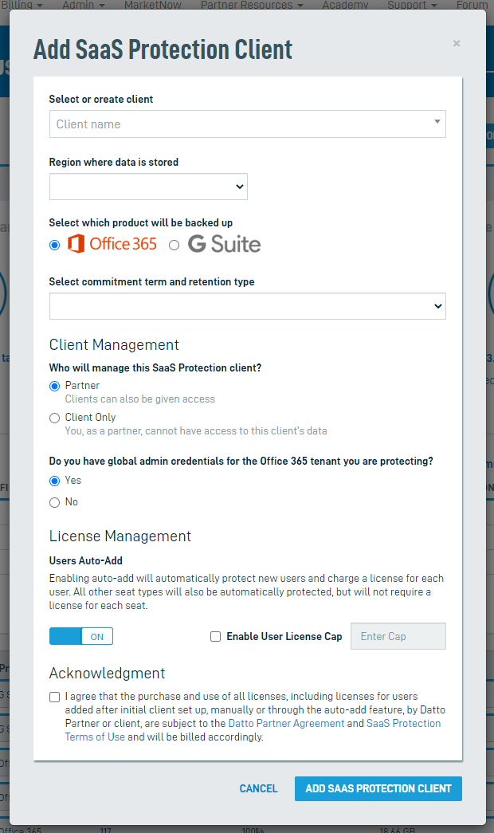Figure 3: The New SaaS Account dialog window
4. Once you finish selecting the Add SaaS Client options, click the Acknowledgment check-box, then click the Add SaaS Client button. Depending on which service you are backing up, the system will redirect you to either the Microsoft log in page or the G Suite account validation page.

Steps for Office 365
Log in with your Microsoft account credentials.
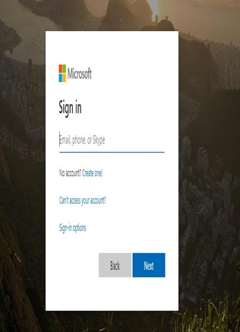
Figure 4: The Microsoft login page

Navigate back to the Datto Partner Portal. From the Datto Partner Portal, click the Status tab then SaaS Protection Status.
Locate the client you have just created, then click on the client name to go to the Datto SaaS Protection dashboard. Initial backups will begin automatically.
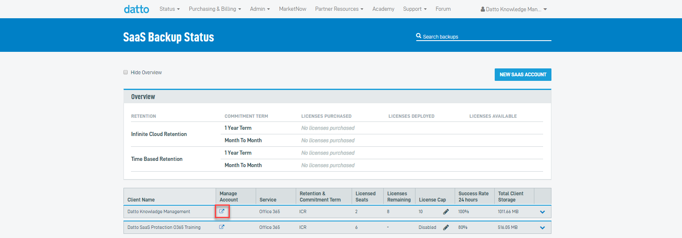Figure 5: The SaaS Protection Status page
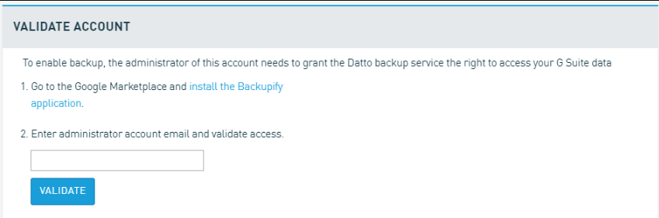Figure 19: The Microsoft log in page
2. Navigate back to the Datto Partner Portal. From the Datto Partner Portal, click the Status tab and select SaaS Protection Status.
3. Locate the client you have just created, then click on the client name to go to the Datto SaaS Protection dashboard. Initial backups will begin automatically.
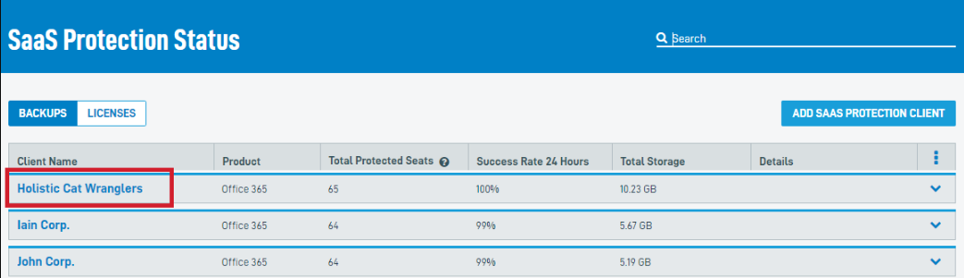Figure 20: The SaaS Protection Status page
Creating an NFR account
Datto offers its paying partners access to Datto SaaS Protection for Office 365 and Datto SaaS Protection for G Suite at no charge for training and demonstration purposes through a Not-for-Resale (NFR) program. For more information, see Datto SaaS Protection: Not for Resale (NFR) program for Datto SaaS Protection

Additional Resources
- Datto SaaS Protection: What's new in Datto SaaS Protection 2.5?
- Datto SaaS Protection: Not for Resale (NFR) program for Datto SaaS Protection
- Datto SaaS Protection: How do I opt in to Datto SaaS Protection through the Datto Store?
- Datto SaaS Protection: Understanding licensing and commitment terms
- Datto SaaS Protection: Adding a new partner-managed Datto SaaS Protection client without client credentials
- Datto SaaS Protection: Adding a new client-managed Datto SaaS Protection account without client credentials
- Datto SaaS Protection: Setting your license cap

Datto SaaS Protection: Adding a new client-managed Datto SaaS Protection account without client credentials
Use this procedure to set up a Datto SaaS Protection account for your customer in cases where they will manage the account, and you will not have access.

Add the client account
1. In the Datto Partner Portal, click the Status tab, then select SaaS Protection Status from the drop-down menu.
Figure 1: The Datto Partner Portal
2. Click the Add SaaS Client button.
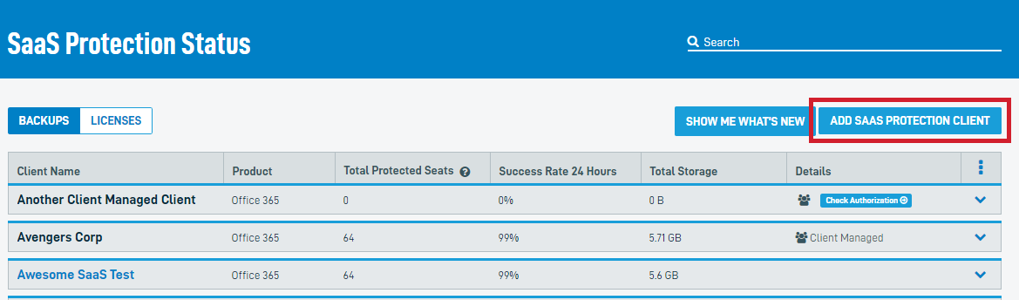Figure 2: The SaaS Backup Status page
3. The New SaaS Account dialog box will appear. Click the Select or Create Client drop-down menu. If the client already exists, select them from the drop-down menu. Otherwise, select Create New.

Adding the client
- Select or create a client:Enter a new client's name, or select an existing client from the drop-down menu.
- The region where data is stored:Choose the geographically appropriate storage region.
- Select which product will be backed up:Choose Office 365 or G Suite.
- Select commitment term and retention:Choose a1 yearormonth-to-monthcommitment term, then chooseInfinite Cloud Retention (ICR)orTime Based Retention (TBR). See Understanding licensing and commitment terms to learn more.
- For the option, Who will manage this SaaS Protection Service? select Client Only.

Service Management
- Under Select or create client user, enter the client's first name, last name, email address, country code, and mobile phone number in the appropriate fields. You will only be able to select a user if you selected a pre-existing client as part of this process.

License Management
- Users Auto-Add: Enable Auto-add to automatically charge a license and add new users as the system discovers them.
- Enable User License Cap: This feature caps the number of licenses the system can use through Auto-Add. Select this check-box to activate the license cap, then use the Enter cap field to select the license cap number.

Acknowledgment
- Once you finish selecting the Add SaaS Client options, click the Acknowledgment check-box, then click the Add SaaS Client button. The system will redirect you to the Microsoft or G Suite log in page. Log in with your account credentials.
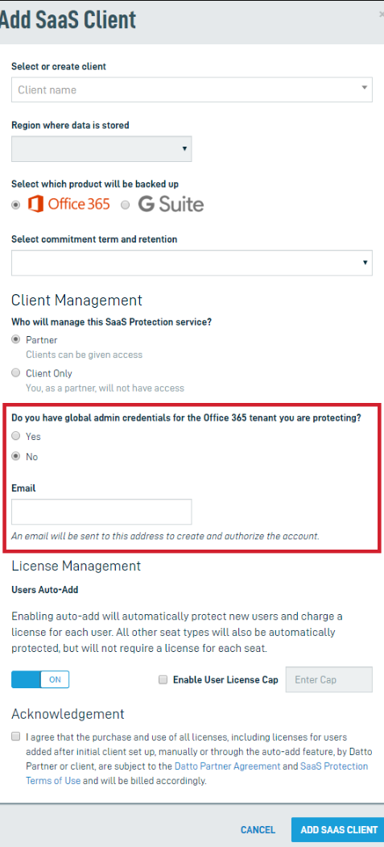Figure 3: The Add SaaS Client dialog box

Have the client authorize the account
After providing the client's information, Datto SaaS Protection will automatically send the new client an email with authorization instructions. The system will create a new account once the client completes the authorization process. For Office 365 clients, this process must be completed using Global Administrator credentials.
The Global Administrator used cannot be the same email as a Datto Partner Portal client. The email will need to be removed from the Partner Portal before it can be used to authorize a Datto SaaS Protection client.
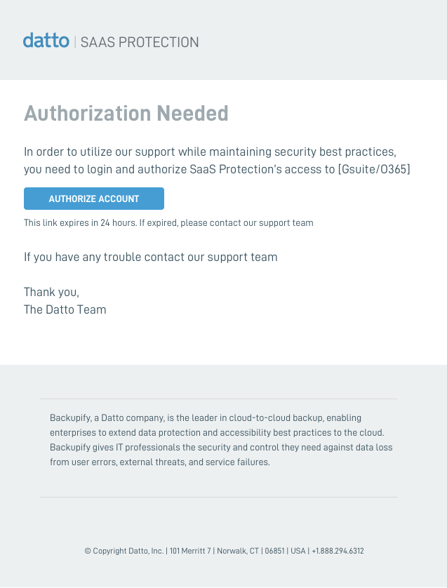Figure 4: The client authorization email
If the authorization link has expired, the partner can restart it by clicking Check Authorization from the SaaS Protection Status page.

Complete the setup
Return to the Datto Partner Portal's SaaS Protection Status page. You will see a label titled Check Authorization in the Details column. When your customer completes the account authorization, that label will disappear, and the account will begin protecting seats.
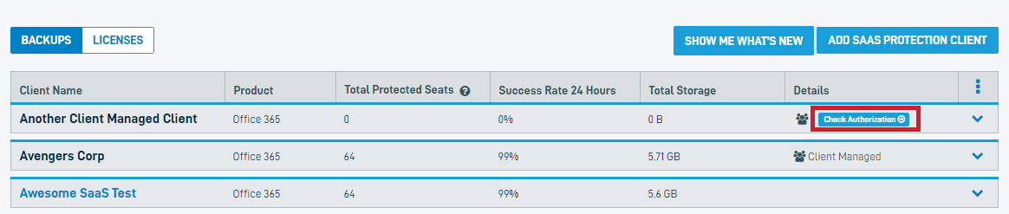Figure 5: The SaaS Protection Status page

Datto SaaS Protection: Create a new Office 365 client for distributors [e.g. PAX8]
You must have Global Admin account credentials to the customer's Office 365 tenant.
To complete the setup and purchase, the partner must have Admin-level permissions in the Datto Partner Portal.

Procedure
Follow these steps to access the SaaS Store and add and authenticate a new Office 365 service for a client.

Clean Browsing
Open a Google Chrome incognito or similar private browsing window. This session will help to avoid confusion about which Office 365 service to authenticate.

Access the SaaS Store
Navigate to http://saasstore.datto.com and enter your Datto Partner Portal credentials. As another option, you can access the Store from the Partner Portal home page by selecting Purchasing & Billing→Store and selecting the SaaS Protection option.
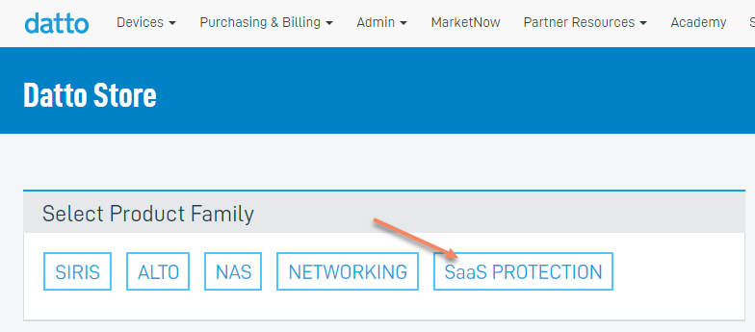
Figure 1: The Datto Store
The SaaS Store is for ordering new products. If your client already uses all Backupify products, or simply wants to increase or decrease their current license count, you should contact your Backupify Sales representative.

Create your customer
If this is the first Backupify account setup, you will see an Add Client screen. If you've already set up previous clients, you will see a Select Client screen, which lets you choose from a drop-down list of existing clients or add a new client.
When creating a new customer, the name you use is for your reference only. Backupify will identify the customer via their domain name.
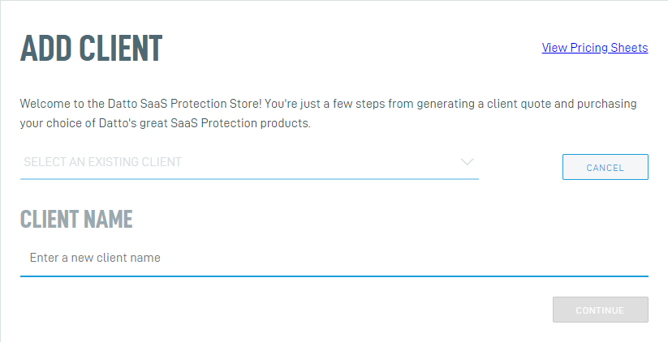Figure 2: Add client

Select the product
Select Office 365 and enter the number of users to protect. When finished, click Generate Quote for pricing information for the tier of users you entered.
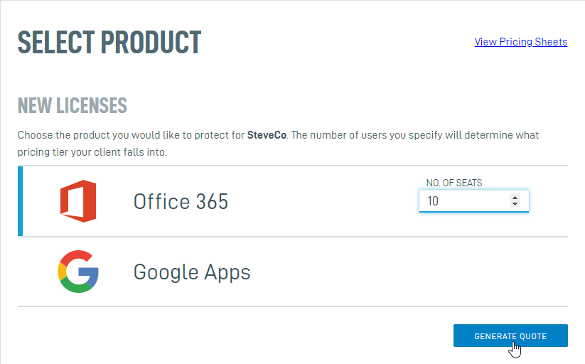Figure 3: Product selection

Confirm the quote
Next, click Confirm Quote to bring up the Payment Method screen containing your payment and contact information. If this is your first time ordering, you must enter all relevant information before proceeding.
For credit card information changes, contact Backupify Support.
Click Confirm Purchase to continue. Click Return to Store to restart the purchase process for other Backupify products.

Manage Clients
To connect Office 365 to the account you've just set up, click Manage Clients/Applications, which opens the Application Management Dashboard.
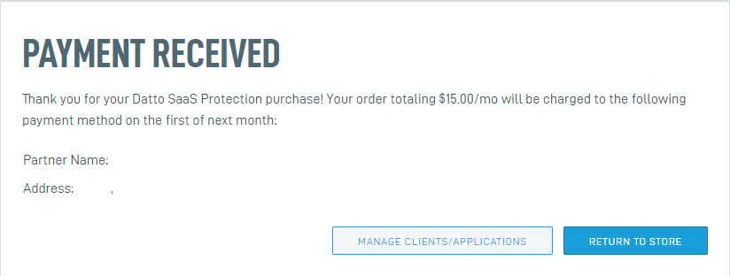Figure 4: Payment confirmation
The client's Office 365 management options will appear in the Application Management dashboard. Click This product is partner-managed on one of the services for which your client has licenses, then agree to the terms and conditions and click Authorize. Datto SaaS Protection will automatically include all other licensed services in the authorization (This dashboard is a one-time setup screen).
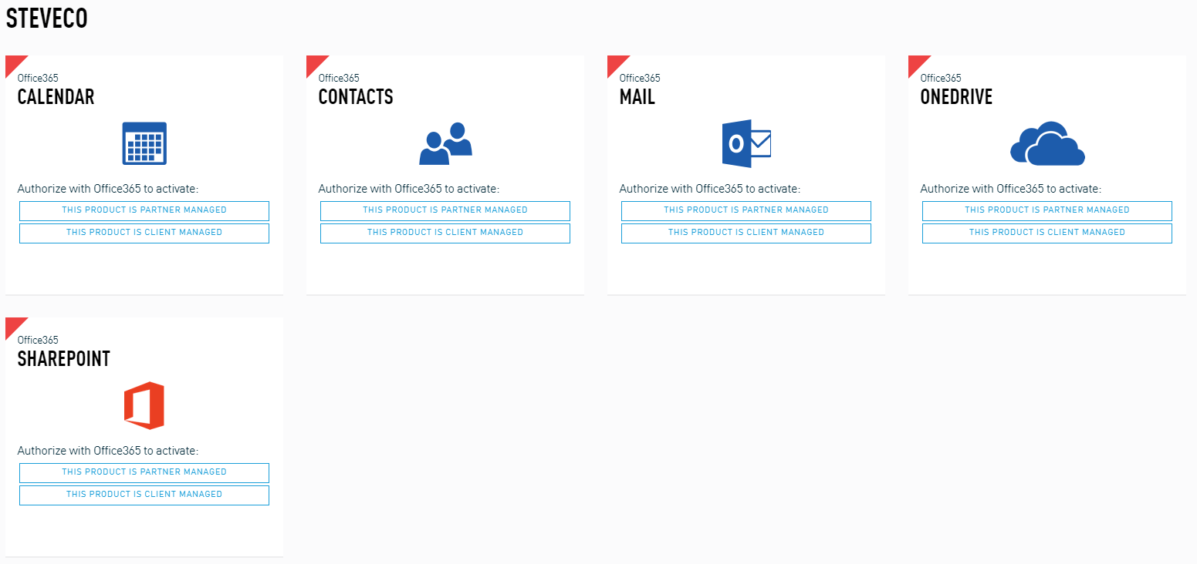Figure 5: The Application Management dashboard

Login to Datto SaaS Protection and complete the onboarding
On the login screen, log into the Microsoft account as a global administrator (the system supports Microsoft modern authentication). Datto SaaS Protection will add your Active Directory. The Active Directory may take several minutes to load.
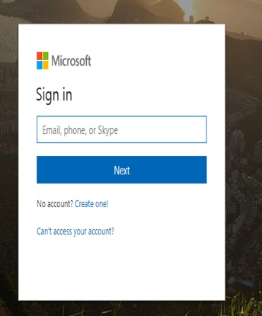
Figure 6: Microsoft Online login screen
You will now see the Backupify Onboarding Wizard. Click Continue.
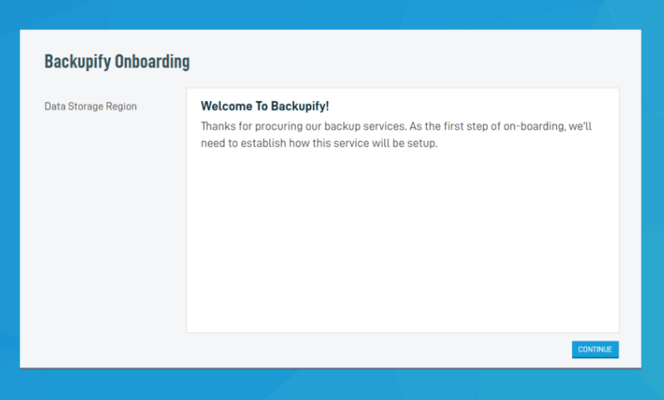Figure 7: The Backupify Onboarding Wizard
Choose the geographically appropriate storage region from the drop-down menu.
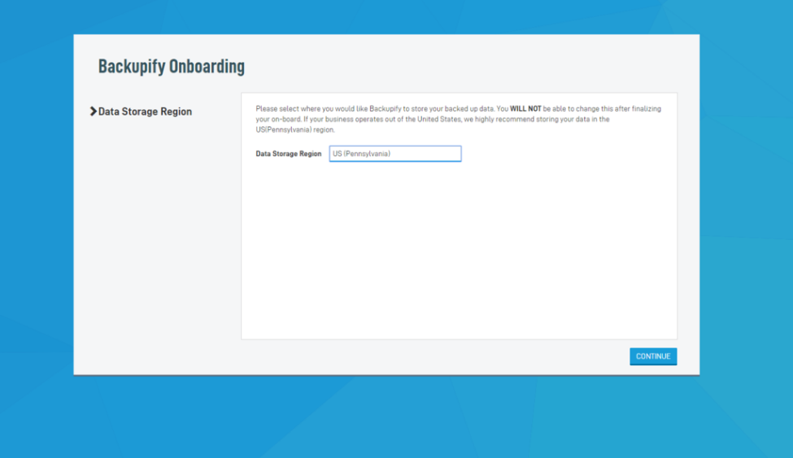Figure 8: Choose a storage region

Add users to the backup
You can now add users to the backup from the Seat Management screen. Auto-Add automatically backs up all users and resources in the domain. Click Disable to manually select which users and resources the system should back up during the initial setup.
With Auto-Add disabled, search for the users you wish to back up in the Add Users field. Click the checkbox for the user you've selected, click Back up selected users, then Confirm to perform a backup for that user. At the bottom of the screen, you can add CSV files of existing user lists and custom site collections from an Excel spreadsheet.
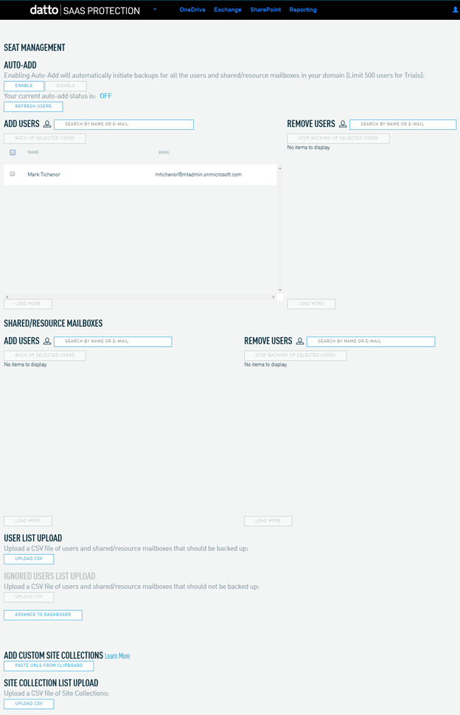Figure 9: Add users to the backup
After adding users, click Advance to Dashboard. Datto SaaS Protection is now protecting your Office 365 apps.
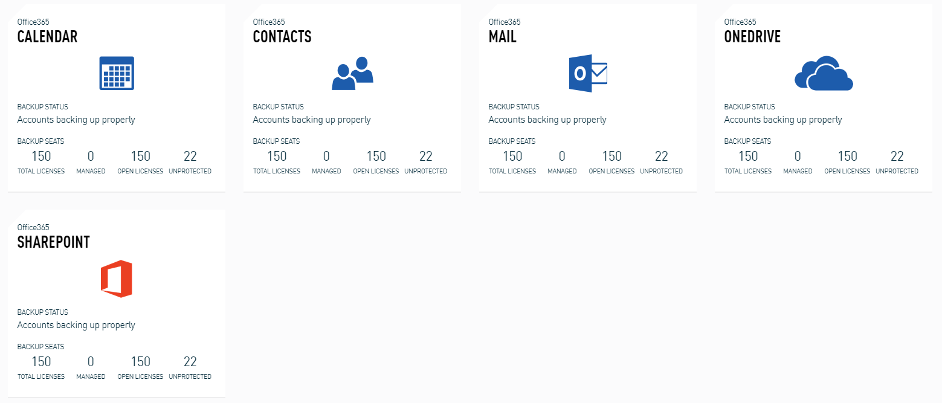Figure 10: The Datto SaaS Protection for Office 365 dashboard
The time zone in Backupify/Datto SaaS Protection is set to GMT by default. This setting is not configurable.

